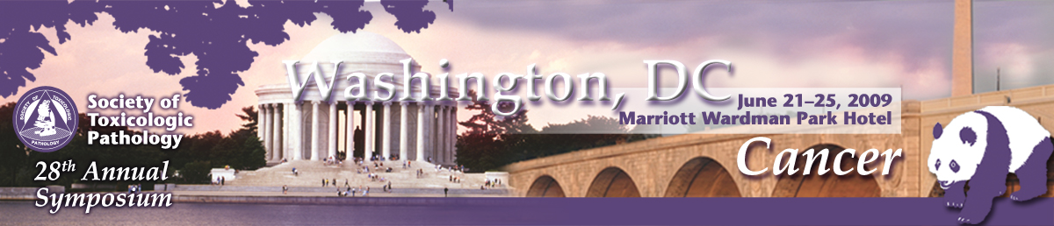

Career Development Premeeting Workshop
Sunday June 21, 2009
Marriott Wardman Park Hotel, Washington, D.C.
(Free to meeting registrants*)

Toxicologic Pathology in a Multicultural World

Presented by the STP Career Outreach and Continuing Education Committees
The workshop will provide interactive sessions covering the challenges of doing business and communicating effectively in two geographical areas of developing business growth; China and India. Presenters include natives of these regions and non-natives with experience interacting in a professional capacity within these cultures. Cultural differences and business styles will be discussed. Differences in the training of professional colleagues, difficulties in scientific translation of reports and messages, and baseline communication skills will be discussed. Workshop presenters will offer ways to enhance the interactions of pathologists of different cultures and explore how to prepare pathologists for effective communication in a global community. This interactive workshop will feature speaker-and-participant discussions of challenging scenarios in toxicologic pathology and real life business case examples will be emphasized.
The Program is sponsored by an educational donation provided by Amgen.

Agenda and Faculty
8:00-8:10 AM Introduction and Agenda
Drs. Eric Schultze (Eli Lilly and Company) and Brian Berridge (GlaxoSmithKline)
8:10-9:50 AM China
Drs. Vincent Meador (Amgen) and Helen Han Hsu (Johnson & Johnson)
9:50-10:20 AM Break
10:20 AM – India
12:00 NOON Drs. Kevin Donnelly (Covance Laboratories, Inc) and VJ Reddy (Eli Lilly and Company)
Who Should Attend?
- Residents or graduate students who are approaching the end of their training programs and are contemplating the next career move
- Experienced scientists interested in improving their communication skills and career advancement
- Any STP member with an interest in expanding his/her career development potential

* Admission is free, but registration is required at www.toxpath.org/AM2009/. (If you have already registered for the Annual Meeting, please email stp@toxpath.org to request addition of this course.) Attendance is limited to the first 100 registrants.

