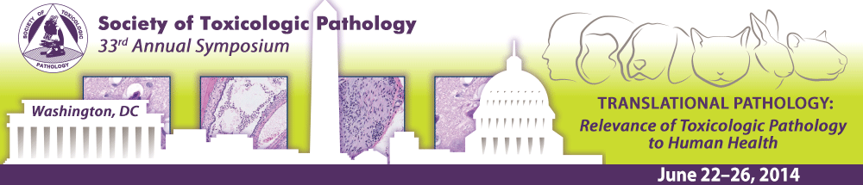

STP Student Member Registration Fee Waived for 2014 Annual Symposium in Washington, DC

STP Student Members
Current STP Student Members may register for the 2014 Annual Symposium for free. STP Student Members may also register to attend Half-day Continuing Education Courses at the discounted fee of $50 for each course.

Nonmember Student Applicants
Nonmember students who apply by April 1 for STP student membership ($30 annual dues) (https://www.toxpath.org/member_app_info.asp) and are approved, can also register for free.
Half-day Continuing Education Courses are offered at the discounted fee of $50 each for all students. http://www.toxpath.org/AM2014/reg.asp.

Additional Student Member Benefits Include
• Access to the members only section of the STP Web site and the on-line directory
• Scientific forum for presentations and publications
• Standardized System of nomenclature and Diagnostic Criteria
• Society’s Journal – TOXICOLOGIC PATHOLOGY (eight on-line issues per year)
• THE SCOPE – (STP on-line quarterly Newsletter)
• ToxPathNet professional network, including ToxPathNet newsgroup access
• Access to PATHWAYS – A Newsletter for Students of Veterinary Pathology

Student Awards:
For more information, please visit the “Student” section of the STP Website.
Feel free to contact STP Headquarters stp@toxpath.org if you have any questions.

